**Software Design Document (SDD)**

**Introduction to the ATM Management System**

A simple banking application, the ATM Management System enables users to carry out routine tasks like cash withdrawals, deposits, and account balance checks. The system keeps track of transactions and uses a PIN to ensure secure authentication.

**Overview of the System**

**There are two primary parts to the system:**

**1. User Interface (UI):** Offers a straightforward menu-driven application that enables the user to conduct banking tasks.

**2. Backend Processing:** Manages transactions, maintains security, and updates account balances. can eventually be connected to databases to store the information.

**Requirements for Function**

**3.1 User Authentication To access the system, users need to input a working Account Number and PIN:**

• Before enabling access, the system checks credentials.

**3.2 Withdrawal of Cash**

• Customers are able to take money out of their accounts.

• Prior to processing the transaction, the system verifies that there is a sufficient balance.

• Following a successful withdrawal, the account balance is updated.

**3.3 Cash Deposit:** Customers have the option to add funds to their accounts.

• The current balance is increased by the amount deposited.

**3.4 Balance Inquiry:** Users are able to see how much balance they have available.

• The account balance is retrieved and shown by the system.

3.5 Exit: The ATM system allows users to safely log out.

**Non-Functional Requirements**

**• Security:** Account information and PINs are encrypted by the system**.**

**• Availability:** The system ought to be accessible at all times.

**• Usability:** A straightforward menu-driven interface makes it simple to use.

**• Performance:** Transactions are processed quickly.

**System Design**

**5.1 Use Case Diagram**

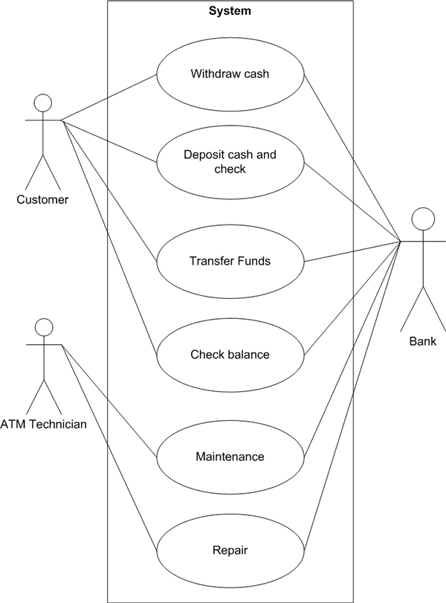

**5.2 Entity-Relationship Model**

|  |  |
| --- | --- |
| **Entity** | **Attributes** |
| User | Account Number, PIN, Name |
| Account | Account Number, Balance |
| Transaction | Transaction ID, Type, Amount, Date |

**5.3 Flowchart (Cash Withdrawal Example)**

1. The user inputs their PIN and account number.

2. Credentials are verified by the system.

3. The user decides to withdraw cash.

4. The user inputs the amount of the withdrawal.

5. The system verifies the balance:

* If there is a sufficient balance, deduct the amount and distribute the money.
* Otherwise, show the message "insufficient balance."

6. Adjust the balance on the account.

7. Show the confirmation message.

**Conclusion**

This document lays out a simple and efficient design for an **ATM Management System** that covers essential banking operations. The goal is to provide users with a seamless experience while ensuring security and reliability.